Final dissemination workshop of EMRP projects
AIM QuTE, GraphOhm and Q-WAVE
Czech Metrology Institute, Prague, 18th-19th May 2016
Location: Hvožďanská 2053/3, 148 00 Prague

Schedule

18th May, Wednesday
Time | Item | Presenter
Block 1 – Only for JRP participants
14:00 – 15:00 | Closed project meetings in parallel for  AIM QuTE, GraphOhm, Q-WAVE | JPR Participants
15:00 – 15:30 | Coffee break
Block 2 – JRP participants, stakeholders
15:30 –18:00 | GraphOhm training course | JRP Consortia, Stakeholders
15:30 –18:00 | Open discussions about coming projects | JRP Consortia, Stakeholders
Block 3 – JRP participants, stakeholders
20:00 – ? | Dinner at downtown

19th May, Thursday
Time | Item | Presenter
Block 1 – Public
8:00 – 9:00 | Registration, preparation of posters
9:00 – 9:10 | Introduction, welcome | Jiří Tesař (CMI)
9:10 – 9:40 | AIM QuTE project – overview | Luis Palafox (PTB)
9:40 – 10:10 | GraphOhm project – overview | Franz J. Ahlers (PTB)
10:10 – 10:40 | Q-WAVE project – overview | Johannes Kohlmann (PTB)
10:40 – 11:00 | Coffee break
11:00 – 12:00 | Poster session
12:00 – 13:00 | Lunch
13:00 – 15:00 | Poster session
15:00 – 15:30 | Coffee break
15:30 – 15:45 | Summary of discussions about impedance | Luis Palafox (PTB)
15:45 – 16:00 | Summary of discussions about Graphene | Franz J. Ahlers (PTB)
16:00 – 16:15 | Summary of discussions about sampling | Johannes Kohlmann (PTB)
Block 2 – JRP participants, stakeholders
16:15 – 18:00 | Kick-off meeting for QuADC | Ralf Behr (PTB)

20th May, Thursday
Time | Item | Presenter
Block 1 – Only for JRP participants
9:00 – 10:00 | Kick-off meeting for QuADC | JPR Participants
10:30 – 11:00 | Coffee break
11:00 –12:30 | Kick-off meeting for QuADC | JPR Participants

How to get to CMI
Address: Czech Metrology Institute, Hvožďanská 2053/3, 148 00 Prague
To get information about Prague public transport, use Googlemaps or DPP.cz
Recommended two ways from Vaclav Havel Airport Prague:
- Take bus No. 119 to station Nádraží Veleslavín, then change to metro line A and go to station Muzeum, where change to metro line C and go to station Chodov,
- or take bus No. AE to station Hlavní nádraží, then change to metro line C and go to station Chodov.
Then walk approximately 10 minutes to CMI (see blue dashed line on the map).

Recommended way from the main train station Hlavní nádraží:
Take metro line C and go to station Chodov.
Then walk approximately 10 minutes to CMI (see blue dashed line on the map).

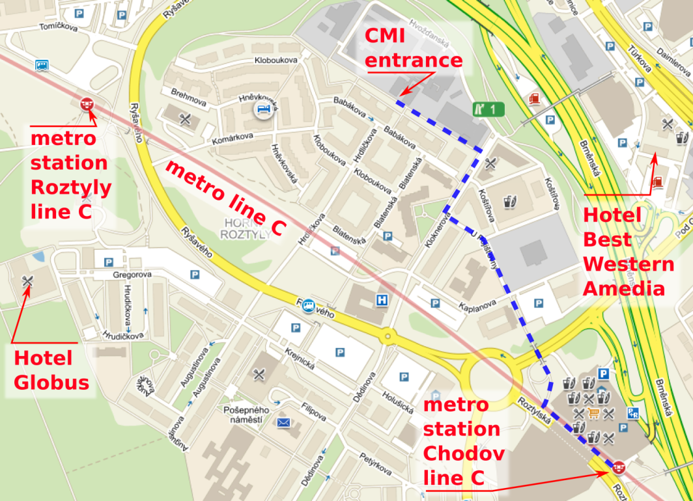

Hotels near CMI
There are plenty of hotels in Prague downtown, you can check e.g. booking.com. When you prefer to stay near CMI site, Hotel Globus or BEST WESTERN Amedia Praha are available.

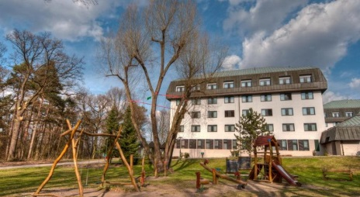
Hotel Globus
Gregorova 2115/10, CZ - 148 00 Prague 4
Phone: +420-296 799 100; 296 799 504
Fax: +420-296 799 560
E-mail: rezervace@hotel-globus.cz
Web: http://www.hotel-globus.cz/cs/home
Use a reservation promo code CMI
Price: single room: 34€, double room: 41€, breakfast included.

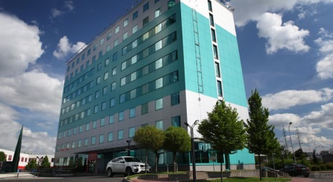
BEST WESTERN Amedia Praha
Turkova 5a/2318
Prague, 149 00, CZ
Phone: +420 234623100
Fax: +420 234623105
Web: http://book.bestwestern.com/bestwestern/CZ/CS/Prague-hotels/BEST-WESTERN-Amedia-Praha/Hotel-Overview.do?propertyCode=89620
Price: double room 56€.

